**C V of DR. RAJASHREE MOHANTY**

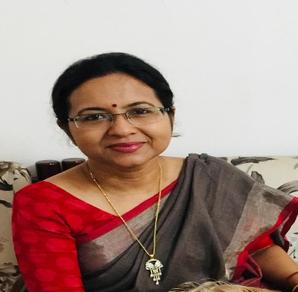

**NAME: DR. RAJASHREE MOHANTY**

**DESIGNATION : READER IN ECONOMICS**

Contact No.: **9437283531**

Email: **mohanty.rajashree1@gmail.com**

|  |
| --- |
| **EDUCATION :** |

**Qualifications:** **M. A, M.Phil.,Ph.D**

**Title of PhD Thesis: Economics of Displacement NTPC ,Kanika- A Case Study.**

|  |
| --- |
| **PUBLICATIONS PROFILE :** |

* **IMPACT OF DISPLACEMENT-ODISHA REVIEW PG-67, VOL- XVII NO.-2 & 4 ,2011**
* **BIKASH AND BISTAPAN-YOJANA ,PG-32 ,,2011**
* **DISPLACEMENT & GOVERNANCE –PUBLIC ADMINSTRATION , PG-101, VOL-XII**

**SEMINARS ATTENDED:**

* **State Level Seminar on Special Economic Zone – Industrial Progress & Human Displacement .**

**at Jajpur on 25-26 ,Sep- 2011.**

* **92th Indian Economic Association at KIIT University on 27-29 Dec 2009.**
* **National Seminar at Vidyasagar University on 19 Mar 2013.**
* **International Seminar on Gandhiji”s Ideals and Practices – An Instrument of Social Change.**

**at Ekamra College on 27-nov 2019.**

* **National Seminar on Violence Against Women in Contemporary Society at Ekamra College on 25 jan 2020.**
* **Gender Budgeting at Gopabandhu Academy on 24-26 Nov 2016.**

|  |
| --- |
| REFRESHER COURSES: |

* **2003 UGC Refresher course at IIITMTM on 14-28 July 2003**
* **2005 UGC Refresher course at Utkal University on 01-01-2005 to 21-02-2005.**
* **2016 UGC Refresher course at Utkal University on27-06-2016 to 17-07-2016.**