**SLOW LEARNER**

Supporting students who face learning challenges requires a multifaceted approach that fosters an inclusive and encouraging educational environment. While avoiding labels that may carry social stigma, institution implements various strategies to assist these learners:

**1. Individualized Attention and Mentorship**

Faculty members engage with students through mentorship programs, addressing their specific issues and challenges both in group settings and on an individual level. This personalized guidance helps in identifying and overcoming academic hurdles.

**2. Remedial and Tutorial Sessions**

Organizing remedial classes or tutorials offers additional support, allowing students to grasp fundamental concepts at their own pace. These sessions provide targeted assistance to reinforce learning.

**3. Parental Involvement**

Conducting Parent-Teacher Meetings (PTMs) educates parents on how to support their children effectively. By understanding their wards' academic and personal development, parents can contribute positively to their progress.

**4. Encouragement of Participation**

Encouraging students to participate in various institutional activities promotes engagement and boosts confidence, contributing to their overall development.

**5. Creating a Supportive Learning Environment**

Establishing a positive and encouraging atmosphere . This includes using positive reinforcement, celebrating individual progress, and providing emotional and social support. Such an environment fosters acceptance and understanding, essential for students facing learning challenges.

**6. Clear and Consistent Expectations**

Providing clear instructions and maintaining consistent routines help students understand what is expected of them, reducing confusion and building confidence. This structure supports their learning process effectively.

**7. Collaborative Learning and Peer Support**

Encouraging group activities and peer tutoring fosters a sense of community and allows students to learn from each other. This collaborative approach enhances understanding and social skills.

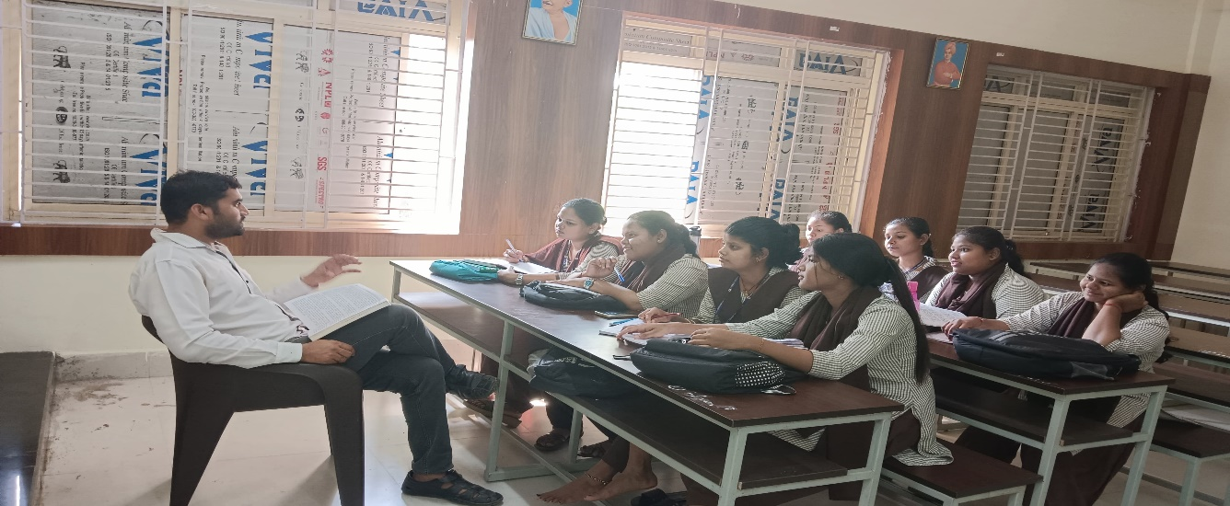

**Remedial Classes For slow learners**